IBM ASSIGNMENT- 1

Name: Sherlin A G

Reg No: 212919205043

My project is an robotic arm which performs the task like pick and place . servo motor used in this circuit and potentiometer is used to control the servos

Circuit Layout:

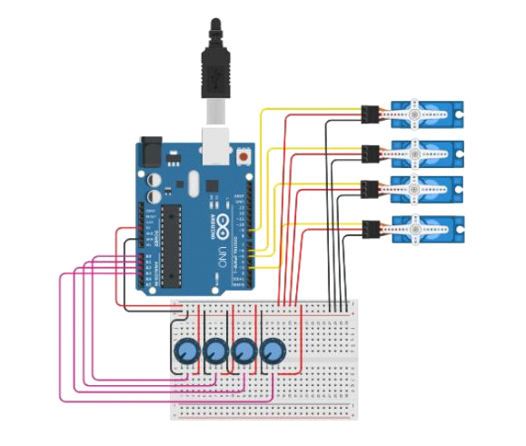

Code:

#include <Servo.h>

Servo myservo1; // create servo object to control a servo

Servo myservo2;

Servo myservo3;

Servo myservo4;

Int potpin1 = 0; // analog pin used to connect the potentiometer

Int potpin2 = 1;

Int potpin3 = 2;

Int potpin4 = 3;

Int val1; // variable to read the value from the analog pin

Int val2;

Int val3;

Int val4;

Void setup() {

Myservo1.attach(9);

Myservo2.attach(6);

Myservo3.attach(5);

Myservo4.attach(3);// attaches the servo on pin 9 to the servo object

}

Void loop() {

Val1 = analogRead(potpin1); // reads the value of the potentiometer (value between 0 and 1023)

Val1 = map(val1, 0, 1023, 0, 180); // scale it to use it with the servo (value between 0 and 180)

Myservo1.write(val1); // sets the servo position according to the scaled value

Val2 = analogRead(potpin2); // reads the value of the potentiometer (value between 0 and 1023)

Val2 = map(val2, 0, 1023, 0, 180); // scale it to use it with the servo (value between 0 and 180)

Myservo2.write(val2);

Val3 = analogRead(potpin3); // reads the value of the potentiometer (value between 0 and 1023)

Val3 = map(val3, 0, 1023, 0, 180); // scale it to use it with the servo (value between 0 and 180)

Myservo3.write(val3);

Val4 = analogRead(potpin4); // reads the value of the potentiometer (value between 0 and 1023)

Val4 = map(val4, 0, 1023, 0, 180); // scale it to use it with the servo (value between 0 and 180)

Myservo4.write(val4);

Delay(15); // waits for the servo to get there

}

Output:

